The Rosary Catholic Primary School

RELIGIOUS EDUCATION POLICY

Based on the values and principles of the UN Convention on the Rights of the Child.

2025 - 2026

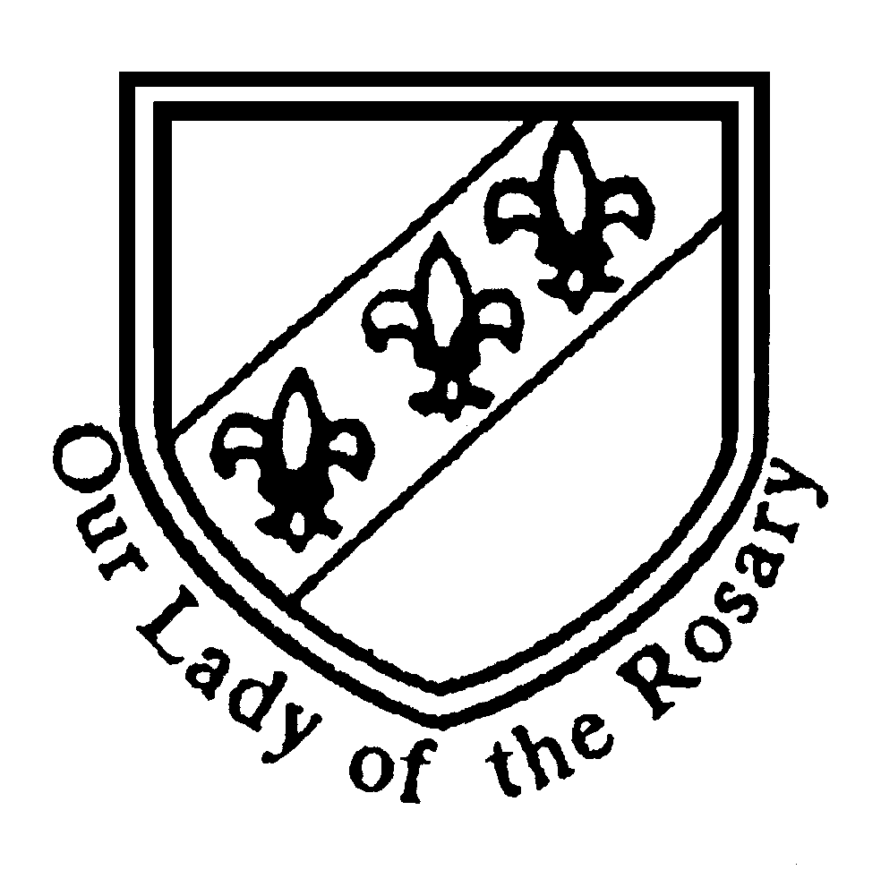

“Jesus Christ, son of Mary, Son of God, is the centre of the Rosary community where we live, love and learn together”

RRSA Article 3
The best interests of the child must be a
top priority in all decisions and actions that
affect children.

RRSA - Article 14
You have the right to choose your own religion
and beliefs. Your parents should help you decide what is right and wrong, and what is best for you.

Article 30
You have the right to practice your own culture, language and religion - or any you choose. Minority and indigenous groups need special
protection of this right.

Policy for Religious Education

Aims of Religious Education

“True education is directed towards the formation of the human person in view of his final end and the good of that society to which he belongs and in the duties of which he will, as an adult, have to share.”
(Vatican 2 “Gravissimun Educationis” 1)

Religious Education has an important role for the development of pupils’ spiritual, moral, social, vocational and cultural development. Our pupils will be respectful and open-minded towards others with different faiths and beliefs and develop their sense of identity and belonging through self-awareness and reflection.

At The Rosary Catholic Primary School we aim to fulfil our Mission Statement through the delivery of the curriculum and through the delivery of those messages inherent in the values which we share and which permeate through all areas of school life.

Religious Education for us is not solely about developing each child’s religious knowledge. It is concerned with providing opportunities and experiences through which each child can grow and develop in their faith and spirituality. It is also concerned with providing a moral code, based on the teachings of Christ. Furthermore, it is concerned with providing opportunities whereby each child can experience expressions of our Catholic culture and heritage.

The pre-school experiences of our pupils means that for some children “RE will be received as catechesis, deepening and enhancing their personal faith” but “for others it will be evangelisation, the first time that they will have been presented with the main truths if living faith.”
(Introduction: “Learning and Growing as the People of God”)

Clearly these aims demand that Religious Education achieves a status which reaches beyond the realms of the core curriculum subjects. Indeed these aims are only achieved through membership of the community here at The Rosary Catholic Primary School it is the partnership between school, home and parish which provides the full range of opportunities through which religious experience, faith and knowledge can be developed.
How we meet our stated aims

In order to achieve these aims RE is presented through the following strands;

- The RE Programme of Study
- Opportunities to reflect on vocation as a student at The Rosary School and member of St Teresa of Calcutta MAC.
- Opportunities to explore how we are all called by God by reflecting on how others responding to God’s call as part of Vocation Week.
- Opportunities to explore different faith traditions as part of Multi-Cultural Education
- Opportunities to nurture a deep understanding of their calling to make a positive difference in the world, especially for those who are vulnerable and in need. Rooted in the Gospel and the principles of Catholic Social Teaching, we recognise the dignity of every human person and their shared responsibility for God’s creation.
- Religious practice
- Sacramental Preparation
- Pastoral Care, Behaviour and Discipline
- Links with other Curriculum areas
- ‘Ten Ten’ RHE Programme delivered for all year groups throughout the entire year.

The RE Programme of Study

Entitlement

RE is allocated 10% of curriculum time in line with the expectations of the Archdiocese. This is time tabled and monitored by SLT.

Prayer and liturgy does not constitute teaching curriculum time and is not part of the allocated 10%.

It is suggested that two lessons per week should be allocated to the Programme of Study whilst a third lesson could be story/song/reflective mediation to reinforce that week’s teaching.

Our Nursery class are expected to make provision for the spiritual, moral, social and cultural development of their pupils. As our Nursery is an integral part of this Catholic school we believe the children in our care must be given opportunities to “experience what it is to be part of a Catholic Community.”

(Curriculum Directory for Catholic Schools)

Learning and Growing as the People of God

The school follows the model curriculum strategy published by the Archdiocese in response to the Catechism, the Curriculum Directory and as a continuation of the Curriculum Mapping.

The structure of the Strategy is designed to deliver the elements of the Curriculum Directory in a systematic and progressive order. The common themes delivered annually are those based upon the Liturgical Year.

The strategy covers the following four areas;
- Revelation: teaching about God’s self – revelation
- Church: about the Communion life of Christ
- Celebration: about living the Christian Mystery in worship and prayer
- Life in Christ: about the search for holiness and truth

Other elements such as the Sacraments and Scriptural Knowledge are delivered annually but each year group has a different emphasis and focus and therefore each year group does not study each Sacrament nor the same Scriptural passages.

How we plan Religious Education

The long term planning is contained within the Programme of Study for each year group. The RE Coordinator is responsible for planning out where, when and how long each unit is taught for.

Medium-term planning is the responsibility of the class teacher and is completed by a unit by unit basis according to the long term plan. Master copies of the units have been provided for each year group and the following information has been given to class teachers.

- Use the long term plan to identify the unit to be studied. Photocopy the unit plan and put the start/finish date for the unit
- Highlight the PoS, the teaching strategies, the learning outcomes, differentiation & prayer focus on a short term plan in conjunction with the strategy document. Also highlight any acts of collective worship or other links which you are going to make.
- If you need to make alterations (e.g. doing a different activity than is written) make a note of it on the short term plan.
- If you are changing the order then number the bullet points on the teaching strategies in your order. (teaching strategies are ideas they are not compulsory)
- All teachers are to use the plans provided by the Birmingham Diocese.
- All teachers to highlight AT2/AT3 questions tasks on the plans.

How we Assess, Monitor, Record and Report

The summative assessments of individual pupils in RE is the responsibility of the class teacher.
Teachers report to parents via consultations in the Autumn and Spring Term and by a written report at the end of the school year.

- Marking following the school’s whole school policy at the end of every piece of work
- Observations of lessons
- Traffic light system for every unit
- Book and planning scrutiny
- Termly moderation of work
- Assessment for Learning

Formative assessment is on going through the teachers’ marking and through the verbal feedback given to children. Assessment for learning techniques embedded across the curriculum including R.E.

A programme of assessments has been devised so that comparisons across the whole school can be made, progression by year groups over time can be monitored and that work being assessed is drawn from different areas of study. Assessment Sheets have been provided for each year group and have been provided by the RE Department’s website. The monitoring of assessment is the responsibility of the RE co-ordinator. Data from termly focus assessment is analysed by the R.E Coordinator and reported to the teachers and SLT.

Teachers will use the age-related standards to assess where the children are working at termly. Teachers can use this at a later date to inform planning, pass it on for the next class teachers and to the RE co-ordinator to enable in the monitoring of the curriculum but also to assist in the ordering of resources and in the development of INSET.

A systematic and planned programme of monitoring of R.E is in place and now involves SLT and Faith Council members. The purpose of this is to share exemplary practice but also to provide support so that high quality teaching and learning is embedded throughout the school. The information gathered as part of the planned monitoring, whether that is from books, planning, learning walks or pupil voice will inform future monitoring exercises. It is also used to inform school improvement planning.

How we teach Religious Education

Religion is taught to the whole class. The class teacher, in their planning, will decide the most appropriate approach for that lesson. The work will be adapted to meet the needs of all pupils. Information from formative and summative assessments are used by class teachers to inform the adaptations need but teachers know ongoing assessment is crucial within lessons. Creativity is important within RE and teachers offer opportunities for children to work individually or in partners or as part of a group.

Religious Education seeks to develop both social and affective skills as well as developing knowledge and understanding. It also seeks to develop a range of skills which can be used in other areas of the curriculum, such as thinking, investigating, interpreting, communicating and evaluating.

Equal Opportunities

All children have equal access to the RE curriculum, regardless of gender, religion, culture or special education needs. Wherever possible full participation in all aspects of RE is expected and encouraged.

With regards to the Sacraments all children in Year 3 and 6 are involved in all the preparatory lessons and are invited to the relevant Parish celebrations.

Those who are not able to receive Communion may receive a blessing. Those not able to receive absolution are able to have private reflection during Reconciliation Services.

Sacramental Preparation

Preparation for the Sacraments of Reconciliation and the Eucharist currently take place in Year 3.

The parents are invited to attend a meeting given by the RE Co-ordinator and Parish Priest before the programme begins. The children and their families participate in meetings/services (for each Sacrament).

The Sacrament of Reconciliation is celebrated in the spring term, an ideal time for Reconciliation. The service takes place on a Saturday so that the parents and teachers can support the pupils in this sacrament and the Parish Priest leads it. Before Reconciliation, children have a prayer service with parents to prepare.

Preparation for the Sacrament of Holy Communion takes place in Year 3. The RE Co-ordinator, Headteacher and Parish Priest lead meetings for the parents and their children before the programme begins. The Sacrament of First Holy Communion takes place on a Sunday, during the summer term.

Preparation for the Sacrament of Confirmation takes place in Year 6. The RE Co-ordinator and Parish Priest lead meetings for the parents and their children before the programme begins. Confirmation usually takes place during the Autumn term, during the liturgical season of Advent.

The preparation for each of the Sacraments involves the parents, teachers and Parish Priest. The celebrations of each Sacrament involve the school and parish community.

Pastoral Care, Behaviour and Discipline

“Our aim in Christian moral education is to help the children to grow into mature Christians who will live for the Father in accordance with the teaching of Jesus Christ, in the power of the Holy Spirit.”
(“Veritas”)

Each class has developed its own class charter based on the UN Conventions of the Rights of the Child. The articles which link to the subject area of R.E are articles 14 and 30: You have the right to learn about and practice religion.

Please refer to the relevant policies for Pastoral Care and Behaviour for Learning.

Involvement with Parents and the Parish Community

The parents are positively encouraged to involve themselves with the religious life of the school. They are invited to all school Masses via the weekly newsletter. As part of our work in developing the prayer life of the school, there are a number of planned opportunities where children plan and lead their own prayer experiences and parents are invited to these services. Sacramental Preparation is sent home so that parents can take an active involvement with work being done in school.

There are two opportunities each year for parents to meet formally with teachers to discuss targets and progress. These are in the Autumn and Spring term. The annual reports also detail the progress made which are sent out in the Summer Term .

The celebration of the liturgy is at the centre of the school’s mission and so children and their families are encouraged to attend 9.30am Mass on Sundays.

Mass is central to school life and a planned programme of Masses is in place for each term. The school work with Fr Fanzwa to ensure there are a range of whole school and year group masses, all of which are in Church, led by the staff and children with members of the parish present.

The Governing body support all aspects of RE provision in the school. It has the highest expectations for Religious Education and acts as a critical friend in the school’s work in improving standards.

During Sacramental Preparation the school asks the parish members to act as prayer sponsors for the children.

Many of the children are encouraged to be servers and assist at Parish Masses. The school and parish are linked by The Sunday Catechism lessons and several fund-raising events that take place during the year. e.g. Christmas Fayre/Summer Fayre.

Links with the Community

The children can visit a place of worship as part of the annual ‘Multi Cultural Celebrations’. There are a range of places such as a Hindu Temple, Mosque, Church, Sikh Gurudwara and Buddhist Vihara. The place of worship is different for every year group, so that over the course of their time in school, the children will have had the opportunity to visit all places of worship.

Throughout the course of the school year, we have links with the wider community through our fundraising efforts. These include: The Fireside Centre, St Chad’s Sanctuary and Fr Hudson’s Caritas.

Links with other Curriculum Areas

Religious Education has close links with other curriculum areas. Many of the skills that are developed in RE are skills which are transferable to other subjects.

Writing skills developed in Literacy can be practised and developed within the RE curriculum. Vocabulary is for each unit is explored at the beginning of the unit, throughout the unit and at the end of the unit.

Computing can be used for word processing final pieces of work produced by the children and also as a tool for research e.g. the lives of the saints.

During R.E lessons children are taught about the values and moral beliefs. PSHE programmes offer pupils a greater insight into how our faith should impact on all our everyday lives.

Finally RE has strong links with both History and Geography. In History the study of the Romans can include a study of how the Christians continued to follow the Faith despite their persecution. The Tudors involves the study of the Reformation. In Geography it is possible to do a comparative examination of how Catholics in other parts of the world live and practise their faith e.g. the celebration of Marde Gras. Geography also allows students to explore their vocation as stewards of God’s creation through environmental issues and our responsibility to live simply and sustainably.

Catholic Social Teaching is embedded in the mission of the school and opportunities are carefully planned to explore the different elements of this, not only as part of the Religious Education curriculum but across the whole curriculum so that teaching is through a Catholic perspective.

RHE Programme

Throughout the year, we deliver the Diocesan advised family life programme – Ten Ten ‘Life to the Full’. This is carried out in conjunction with the class teachers, our mentors and SLT. The school liaises with parents prior to the programme being delivered to the children. The aim of the programme is to explore the individual, physical, social, emotional and spiritual development of the children.

RE Coordinator’s Job Description

Teaching and Learning
• Oversee curriculum coverage, continuity and progression in RE throughout the school and ensure it is meeting Diocesan requirements.
• Provide model lessons, model planning and assessment.
• Provide clear guideline of expectations by means of policy and schemes of work.
• Support and guide colleagues to select the most appropriate teaching and learning methods and resources to ensure Catholic life is experienced in all curriculum areas.
• Evaluate teaching and learning by rigorous monitoring by:
- Observation;
- Learning walks;
- Book scrutiny;
- Data analysis of assessment;
- Pupil, staff, SLT and parent interviews;
- External verification.

Leading and Managing Staff
• Lead professional development of staff through example and support to ensure full knowledge and understanding of what RE should be in school and an enjoyable subject to teach and learn.
• Lead staff training and resource them to produce high quality RE teaching with expectations for planning delivery and assessment of RE.
• Support development of the liturgical calendar and link to the school monitoring calendar.
• Lead and support staff to provide school retreats and mission.
• Provide additional support for non-Catholic teachers.
• Ensuring staff have access to CPD in RE.
• Providing feedback to staff about local, Diocesan and National developments in RE.

Accountability
• Annually evaluate ‘the Catholic School’s Inspection framework with the Headteacher/Principal, SLT and Governors.
• Communicate effectively, orally and in writing to a range of audiences e.g. staff, students, parents and governors.
• Termly discussion with Headteacher/Principal the progress of RE regarding data and development plan and section 48.
• Keep abreast of all curriculum developments to ensure that Catholic values are supported.
• Ensure that the school environment reflects children’s work in RE.
• Report to Governors as required.

Other Professional Requirements
• Establish and maintain positive effective working relationships with professional colleagues and parents.
• Participate as required in meetings with professional colleagues and parents in respect of the duties and responsibilities of the post.
• Be aware of the need to take responsibility for your own professional development and ensure attendance at Diocesan inset provision.

Health and Safety

Teachers should follow the current procedures when going over to church ensuring they inform SLT and Fr Fanzwa of their intention to visit the church.
All classes must go to church via gate in playground.
Any matches kept in classrooms must be locked away securely.
The teacher is responsible for the lighting of candles and ensuring that lit candles are used safely and extinguished properly.

Legal Right of Withdrawal

Parents of pupils in voluntary academies are permitted, by law, to request that their child is withdrawn from receiving all or part of religious education and/or collective worship given at the school and any such request shall stand until such time that the parent’s request is withdrawn.

RE Coordinator: Mrs A Norris supported by Miss M Driver
Head Teacher: Mrs A Norris
RE Link Governor: Mrs J Jackson

